**NUTRI GARDEN / KAN WADI HUAN HLIMTHLA**

1. **Serchhip District**
2. Chekkawn Anganwadi Centre :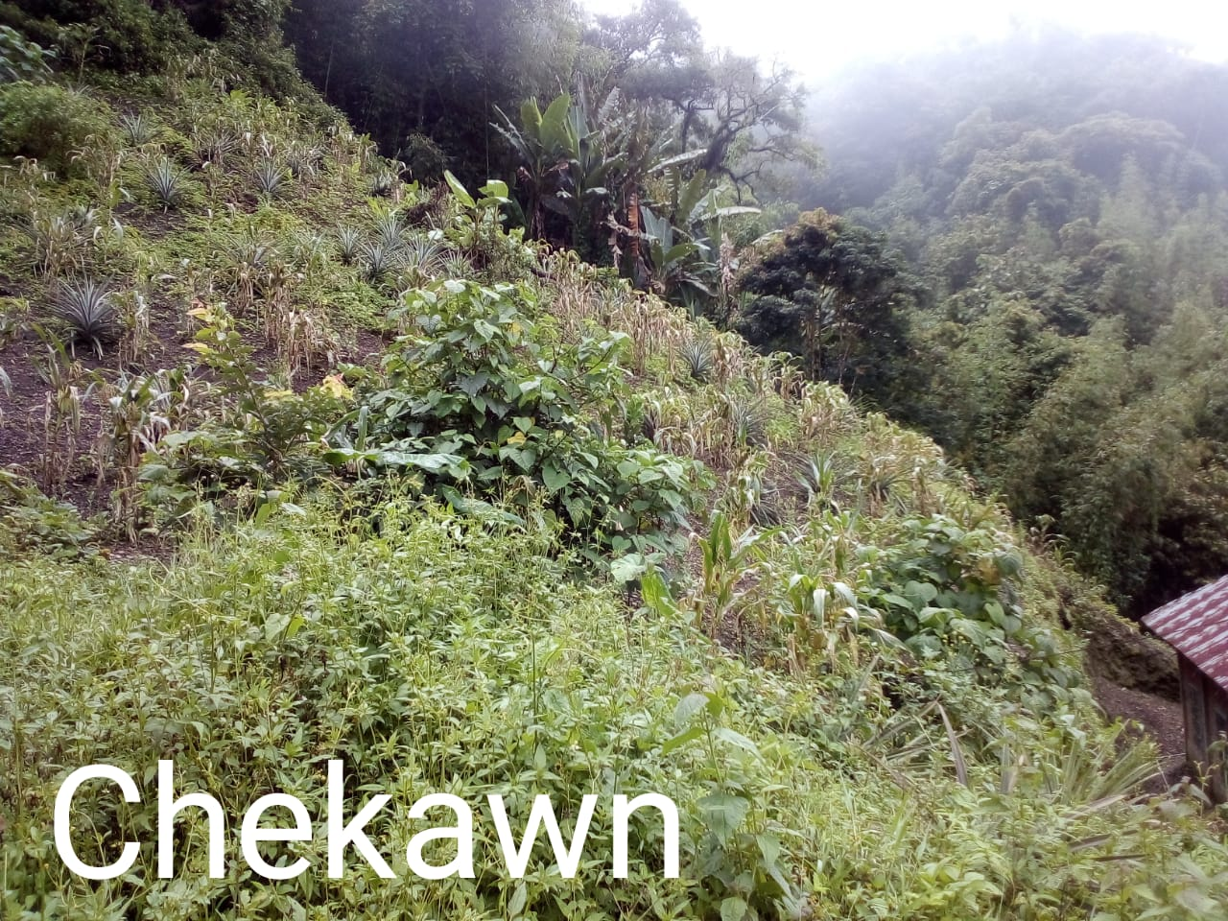
3. Sialhawk V Anganwadi Centre :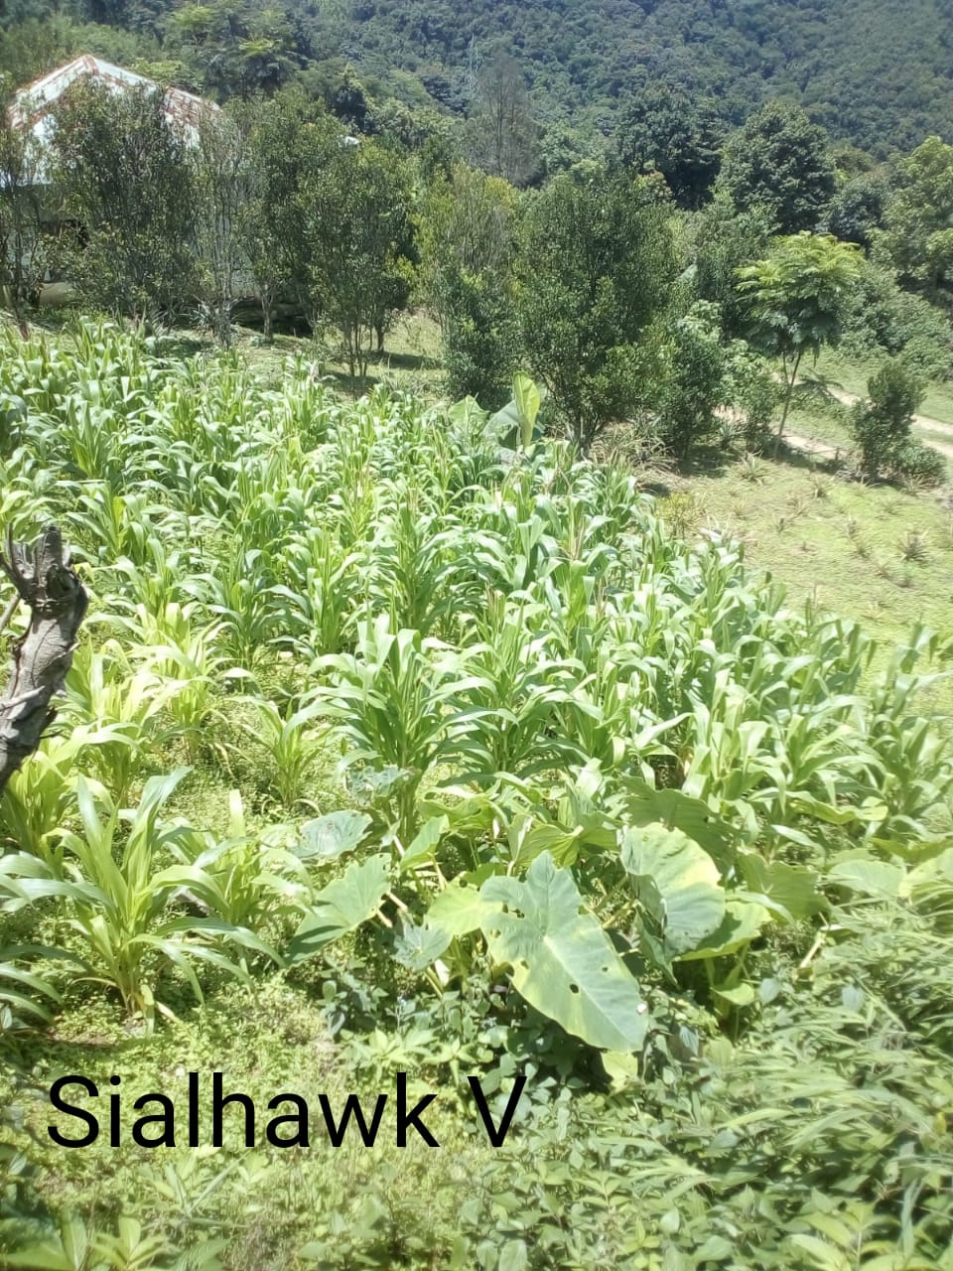
4. East Lungdar III Anganwadi Centre :