**NUTRIGARDENS UNDER AIZAWL DISTRICT**

1. **Sihphir Neihbawih AWC, Tlangnuam ICDS Project, Aizawl District.**

This Nutrigarden is currently prepared for ‘*Model Nutrigarden’* under Tlangnuam ICDS Project.

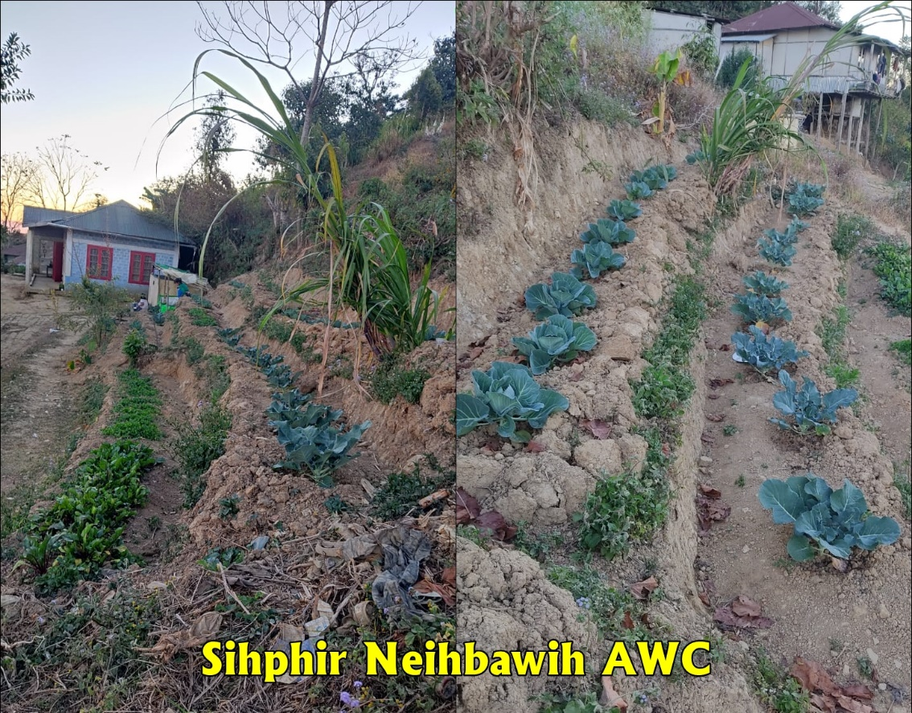

1. **Kepran AWC-III, Darlawn ICDS Project, Aizawl District.**

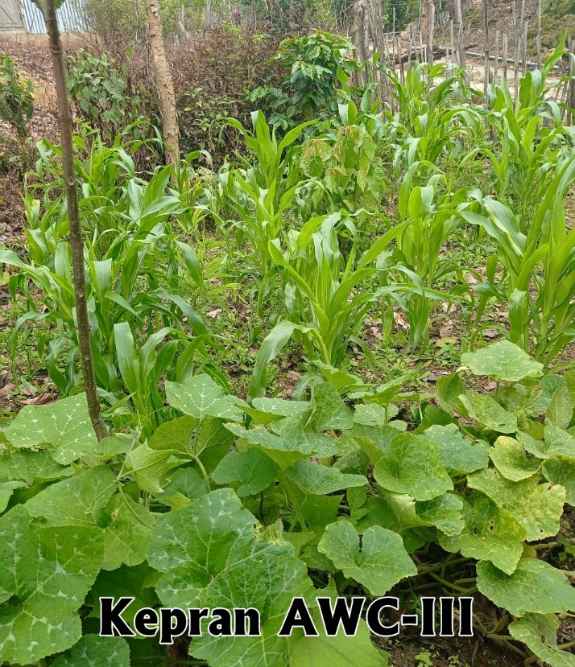

1. 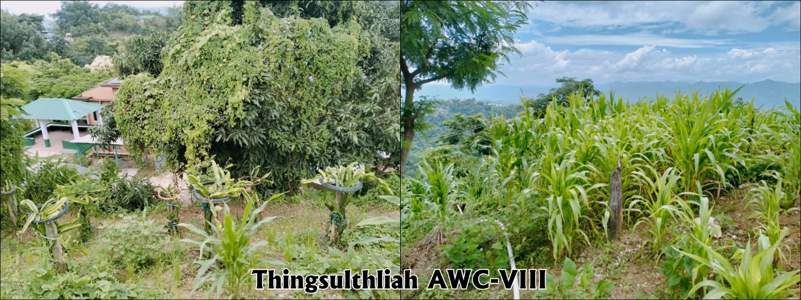**Thingsulthliah AWC-VIII, Thingsulthliah ICDS Project, Aizawl District**
2. **Sesawng CTI AWC-II, Thingsulthliah ICDS Project, Aizawl District**

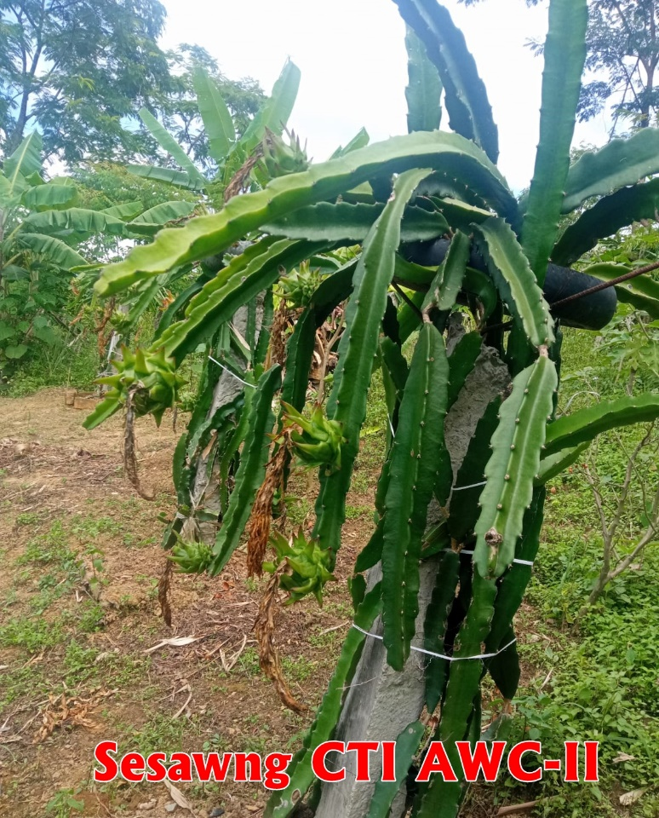

1. **Aibawk AWC-II, Aibawk ICDS Project, Aizawl District**

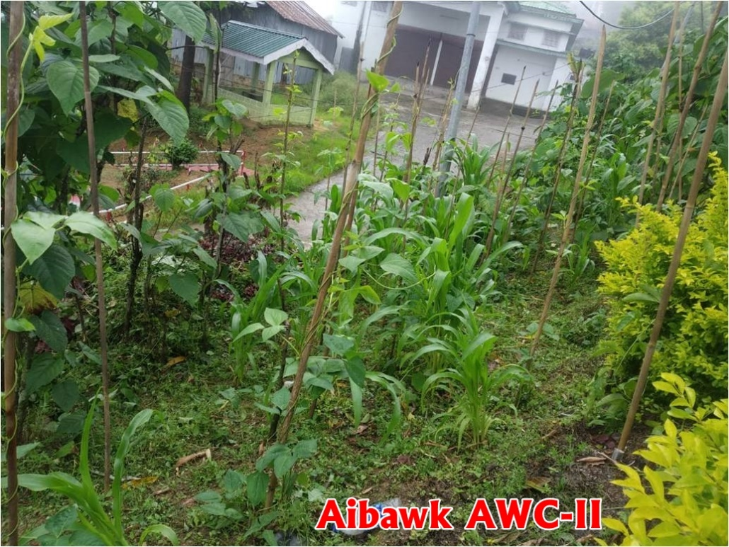

1. 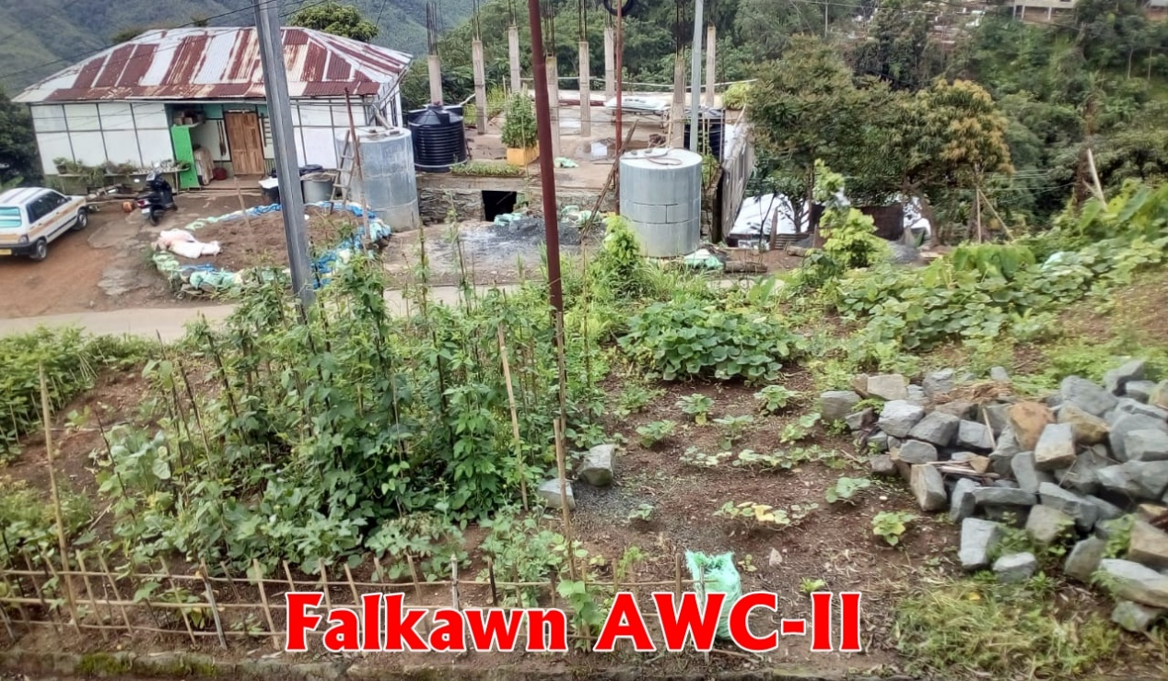**Falkawn AWC-II, Aibawk ICDS Project, Aizawl District**